CSA1413
COMPILER DESIGN
Name: Haresh Kumar N L
Reg No: 192425009
Type Casting Float to Int and Int to Float

Aim:
To write a C program to demonstrate type casting from float to integer and integer to float using automatic and manual type conversion.

Float to Int:
Pseudocode:
START
DECLARE float my_float = 12.35
CONVERT my_float to integer automatically
STORE result in auto_int
CONVERT my_float to integer using (int)
STORE result in manual_int
PRINT "Type Casting Float To Int"
PRINT auto_int
PRINT manual_int
STOP

Code:
#include <stdio.h>
int main() {
float my_float = 12.35;
int auto_int = my_float;
int manual_int = (int)my_float;
printf("Type Casting Float To Int\n");
printf("Automatic: %d\n", auto_int);
printf("Manual: %d\n", manual_int);
return 0;
}

Output:
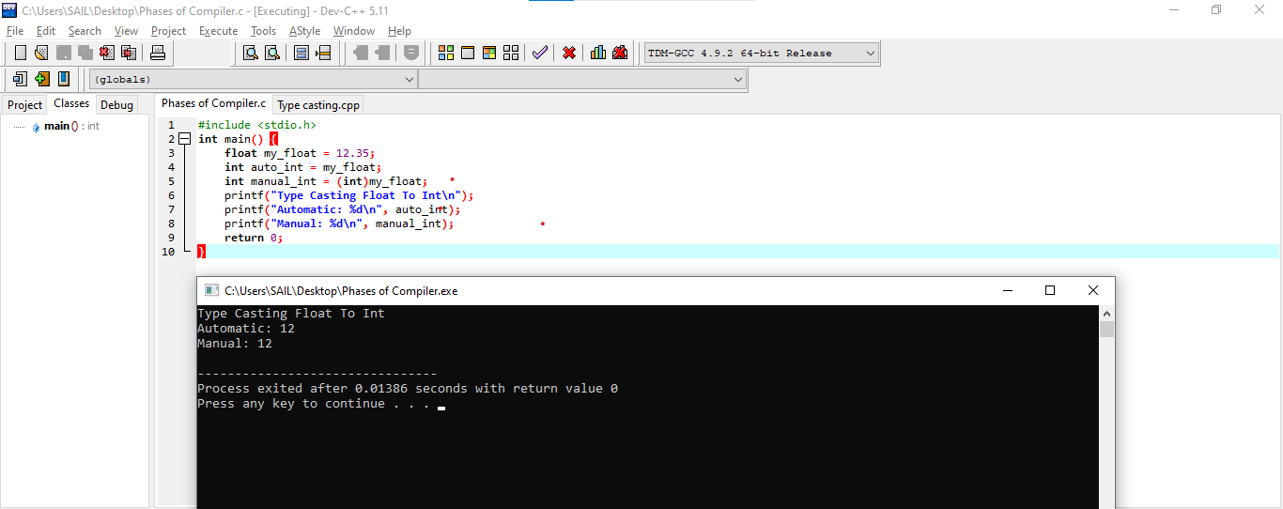

Int to Float:
Pseudocode:
START
DECLARE integer my_int = 7
CONVERT my_int to float automatically
STORE result in auto_float
CONVERT my_int to float using (float)
STORE result in manual_float
PRINT "Type Casting Int To Float"
PRINT auto_float
PRINT manual_float
STOP

Code:
#include <stdio.h>
int main() {
int my_int = 7;
float auto_float = my_int;
float manual_float = (float)my_int;
printf("Type Casting Int To Float\n");
printf("Automatic: %f\n", auto_float);
printf("Manual: %f\n", manual_float);
return 0;
}

Output:
